

Volunteer Officer

Recruitment Pack December 2025







Contents

About us 3

The role 4

Job description 5

Person specification 8

The recruitment process 9

Contact us 9

If you need this information in another format please contact us.

About us
Healthwatch Wakefield are the local health and social care champion for Wakefield District. From Airedale to South Kirkby, Overton to Knottingley, and everywhere in between, we make sure NHS and Social Care leaders hear peoples experiences and use their feedback to improve care.
Find out about some of our recent achievements in our Annual Report here:
https://www.healthwatchwakefield.co.uk/wp-content/uploads/2025/06/Healthwatch-Wakefield-Annual-Report-2024-25.pdf
We are a Registered Company No. 09907848 and Charity No. 1166797 Registered in England and Wales.

Organisational tree
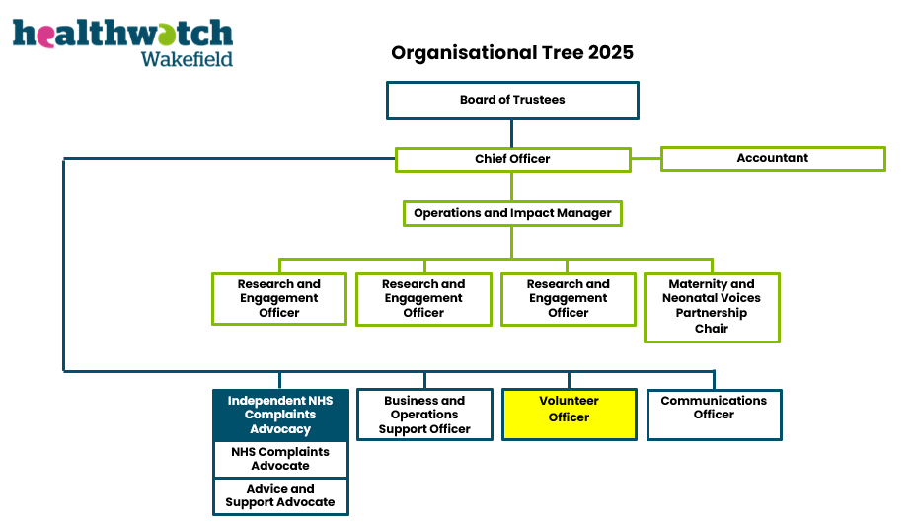
This chart will change depending on the contracts we have at the time. This role is highlighted in yellow.

The role

Overview
We are looking for an enthusiastic Volunteer Officer to plan and deliver our new Volunteer Strategy. This role involves leading and coordinating our voluntary role holders across different roles and integrating with the wider work of the team.
We want someone who is passionate about volunteers and who will rise to the challenge set by our Chief Officer for all our work to have a clear fingerprint of volunteers demonstrated. The post holder will have latitude to develop a modern, exciting, and vibrant volunteer base and will work across the team to embed new roles which enable us to spread our reach further into the District.
We work closely with the local health and social care system to use our volunteer’s skills and lived experience to support Patient Safety Walkabouts and Patient Led Assessments of Care Environments (PLACE). We also have the power and responsibility to deliver Enter and View visits as a Local Healthwatch organisation. The Volunteer Officer will coordinate and oversee these activities to continue our successful partnership approach.
We are committed to providing social value to the local population, we do this through our opportunities which include volunteering, collaborating, work experience, and placements.

Details
Title: Volunteer Officer
Location: The Plex, 15 Margaret Street, Wakefield WF1 2DQ and Wakefield District
Reports to: Chief Officer
Type: Fixed Term 12 months
Working Hours: Part-time, 22.5 hours per week
Salary: £27,800 per annum (pro-rata)
Pension: 5% employer contribution
Office Location: The Plex, 15 Margaret Street, WF1 2DQ
Benefits include hybrid and flexible working, 28 days holiday per annum not including Bank Holidays (pro rata), access to mental health and wellbeing support through our employee assistance programme, and training and development opportunities.

Job description

Purpose
To have responsibility for the Healthwatch Wakefield Volunteer Strategy. To lead on recruitment, co-ordination, and support of a diverse range of volunteers for Healthwatch Wakefield; including a ‘buddy’ system to help overcome barriers to involvement. To facilitate and maintain an activity and training record, and report on volunteer contributions on a regular basis. To remain up to date with relevant legislation and good practice in volunteering. To review and develop the roles available for volunteers in Healthwatch, working collaboratively with volunteers, contributors and the team.

Healthwatch Wakefield Volunteer Roles

Trustees
Support for the board will be the responsibility of the Chief Officer; the Volunteer Officer is required to support the development of appropriate procedures.

Volunteers
Enter and View visits
Patient and Resident Safety visits in collaboration with the Integrated Care Board (ICB)
Co-production task and finish groups

Contributors
Community and Citizen Panels in collaboration with Panel Coordinators

Placement and work experience projects
Students or others who may join Healthwatch for a time limited period.
There may be scope to develop other volunteering opportunities.

Main duties and responsibilities

Promote and deliver volunteering opportunities
Promote volunteering to potential and existing volunteers.
Carry out engagement in the local community linking with the Research and Engagement team and coordinating volunteer involvement in engagement activities.
Involve volunteers in all Healthwatch projects.
Work with those who are often not heard to make sure they have a voice are given the opportunity to use their experience and take part.

Recruit, induct, support and develop volunteers
To work with the team to plan recruitment to specific roles, reviewing and updating volunteer role descriptions with volunteers and staff members.
Advertise for and recruit volunteers using a range of methods ensuring a diverse volunteer body.
Induct volunteers, including forward planning, support and development, including with a view into employment where appropriate and desired.
Plan, develop, organise and monitor volunteer activities, including maintaining records of activities and training.
Lead and motivate volunteers through supervision and support, and having wider oversight and leadership of other voluntary roles such as placement students and others.
Support the development of volunteers’ knowledge, competence and skills.
To act as a key support and central point of contact for volunteers.
To keep all voluntary role holders informed, updated and engaged with Healthwatch.
To manage volunteer expenses and advise on wider voluntary role expenses

Lead Enter and View visit planning and coordinate patient safety activities
Work with the Chief Officer to plan Enter and View visits as the need arises and coordinate the visiting team around the visit.
Liaise with the ICB to coordinate volunteer involvement with Patient and Resident Safety Walkabouts.
Liaise with the local NHS Trusts to coordinate Patient Led Assessments of the Care Environment (PLACE) visits.
Collate and report on the outcomes of all visits, articulating the impact of this work for the local community and other stakeholders.
Review and deliver Authorised Representative training for volunteers interested in Enter and View visits.
Increase involvement of volunteers in the delivery of all elements of the Enter and View process.

Provide leadership for the volunteer programme
Promote Healthwatch and its services to stakeholders.
With the Chief Officer, manage an expenditure budget for volunteering activities.
Obtain supplies and manage resources for volunteering activities.
With the Research and Engagement Team and others, organise events involving volunteers.
Set quality standards for volunteering and assure effective service provision.
Lead and participate in meetings involving volunteers.
With the Healthwatch Communications Officer, provide information for volunteering
Report to external agencies about the Healthwatch volunteering programme.
Establish links to volunteering networks in the district and region and develop professional knowledge of good practice.
Contribute to the ongoing development of the website by updating the volunteer section on a regular basis.
Utilise a variety of suitable communication methods to keep in contact with our volunteers.

General Responsibilities
Support a positive team environment, ensure compliance with policies, and promote equality and diversity.
Participate in internal and external meetings and contribute to the periodic review of job roles.
Plan and manage own workload, set targets and deadlines, and be self-supporting with regard to administration and IT.
To undertake specific identified projects and any other duties consistent with the nature and level of the post.

Person specification

Essential Criteria
Experience of supporting and supervising volunteers, including recruitment and induction.
Experience of producing systems and procedures for volunteers.
Experience of delivering and co-ordinating training.
Experience of working with a diverse range of communities.
Experience of working in partnership and with external stakeholders.
Experience of report writing.
Communication, facilitating, and liaison skills.
Ability to confidently build and maintain professional relationships.
Ability to work as part of a team and to collaborate with others.
Good planning and organisational skills, including ability to prioritise workload.
Able to work effectively under pressure and to deadlines.
Able to produce succinct, articulate and well-formatted documents and reports.
Ability to understand, interpret and analyse basic financial information
Competence in IT skills and internet use.

Desirable Criteria
Experience of developing a volunteer policy.
Experience of working with volunteers within a health or social care setting.
Experience of managing a project budget.
Knowledge of the third sector in Wakefield District and the environment within which it works.
Knowledge of health and social care structures.

The recruitment process
Submit your CV and cover letter of no more than 500 words to Lewis.Smith-Connell@healthwatchwakefield.co.uk by 11.59 pm on Monday 22 December. Please note that applications which do not include both elements may not be considered.
Interview date is planned for Thursday 15 January.
Join us in making a difference in local health and care services!

Access Requirements for the interview
If you have a disability or health condition that means you need us to make any adjustments to the interview process, please let us know and we will do our best to accommodate these. This will not affect your application.

Base
We are based at The Plex, 15 Margaret Street, Wakefield, WF1 2DQ. This is near to Wakefield College and Newstead House Dental Clinic.
Parking spaces are for the sole use of tenants of The Plex. Parking is available on Margaret Street on a pay and display basis using the ‘MiPermit’ app. Please check the signage. Additional parking is available at Rishworth Street (Short stay), Borough Road (Short stay), Gills Yard (Long stay), and Merchant Gate (Long stay). Alternatively, we are a short walk from Wakefield Bus Station and Wakefield Westgate Railway Station.
If you require a disabled visitor space, please arrange this prior to arrival with a member of Healthwatch Wakefield staff. Please note the disabled parking space is a short distance from the entrance to the building. If you require access to the building via the ramp, please make this known prior to your visit.
On arrival at The Plex please press the doorbell and wait for the door to be answered.

Contact us
If you would like to discuss the role in more detail, contact Lewis Smith-Connell at Lewis.Smith-Connell@HealthwatchWakefield.co.uk.
You can also call the office on 01924 787379 and ask for Lewis if you have any other questions or queries.

Thank you for your interest in Healthwatch Wakefield.

